Research Article

UPPER CASE, BOLD, CENTRED, 12 PT, 1.5 LINE SPACING BEFORE AND AFTER 0 PT
Auther Name SURNAME¹Please leave it anonymized.
¹XXXX University, Faculty of XXXX, City, Country Please leave it anonymized.

ABSTRACTPurpose: Times New Roman 10 pt, 1 line spacing 0 pt before, 10 pt after, justified. Max. 250 words. Times New Roman 10 pt, 1 line spacing 0 pt before, 10 pt after, justified. Max. 250 words. Times New Roman 10 pt, 1 line spacing 0 pt before, 10 pt after, justified. Max. 250 words.
Methods: Times New Roman 10 pt, 1 line spacing 0 pt before, 10 pt after, justified. Max. 250 words. Times New Roman 10 pt, 1 line spacing 0 pt before, 10 pt after, justified. Max. 250 words. Times New Roman 10 pt, 1 line spacing 0 pt before, 10 pt after, justified. Max. 250 words.
Results: Times New Roman 10 pt, 1 line spacing 0 pt before, 10 pt after, justified. Max. 250 words. Times New Roman 10 pt, 1 line spacing 0 pt before, 10 pt after, justified. Max. 250 words. Times New Roman 10 pt, 1 line spacing 0 pt before, 10 pt after, justified. Max. 250 words.
Conclusion: Times New Roman 10 pt, 1 line spacing 0 pt before, 10 pt after, justified. Max. 250 words. Times New Roman 10 pt, 1 line spacing 0 pt before, 10 pt after, justified. Max. 250 words. Times New Roman 10 pt, 1 line spacing 0 pt before, 10 pt after, justified. Max. 250 words.

Article Info
Received: XX Month 202X
Accepted: XX Month 202X
KeywordsAaaaaa,
Bbbbbb,
Cccc ccc,
Dddd dddd.
(Only the first letter of each keyword should be capitalised, alphabetised, minimum 2 and maximum 5 keywords. A full stop should be added at the end).

INTRODUCTION (Main title TNR 12p, large, bold before 0 after 10 pt, 1.5 line spacing, left justified)
Times New Roman 12 pt, 1.5 line spacing before-after 0 pt, justified. 1 cm indent. Only 10 pt should be added after the last line. Times New Roman 12 pt, 1.5 line spacing 0 pt before and after, justified. 1 cm indent. Only 10 pt should be added after the last line. Times New Roman 12 pt, 1.5 line spacing 0 pt before and after, justified. 1 cm indent. Only 10 pt should be added after the last line. Times New Roman 12 pt, 1.5 line spacing 0 pt before and after, justified. 1 cm indent. Only 10 pt should be added after the last line. Times New Roman 12 pt, 1.5 line spacing 0 pt before and after, justified. 1 cm indent. Only 10 pt should be added after the last line. Times New Roman 12 pt, 1.5 line spacing 0 pt before and after, justified. 1 cm indent. Only 10 pt should be added after the last line.Times New Roman 12 pt, 1.5 line spacing before-after 0 pt, justified. 1 cm indent. Only 10 pt should be added after the last line. Times New Roman 12 pt, 1.5 line spacing 0 pt before and after, justified. 1 cm indent. Only 10 pt should be added after the last line. Times New Roman 12 pt, 1.5 line spacing 0 pt before and after, justified. 1 cm indent. Only 10 pt should be added after the last line. Times New Roman 12 pt, 1.5 line spacing 0 pt before and after, justified. 1 cm indent. Only 10 pt should be added after the last line. Times New Roman 12 pt, 1.5 line spacing 0 pt before and after, justified. 1 cm indent. Only 10 pt should be added after the last line (1).
Times New Roman 12 pt, 1.5 line spacing 0 pt before and after, justified. 1 cm indent. Only 10 pt should be added after the last line. Times New Roman 12 pt, 1.5 line spacing 0 pt before and after, justified. 1 cm indent. Only 10 pt should be added after the last line. Times New Roman 12 pt, 1.5 line spacing 0 pt before and after, justified. 1 cm indent. Only 10 pt should be added after the last line. Times New Roman 12 pt, 1.5 line spacing 0 pt before and after, justified. 1 cm indent. Only 10 pt should be added after the last line. Times New Roman 12 pt, 1.5 line spacing 0 pt before and after, justified. 1 cm indent. Only 10 pt should be added after the last line. Times New Roman 12 pt, 1.5 line spacing 0 pt before and after, justified. 1 cm indent. Times New Roman 12 pt, 1.5 line spacing 0 pt before and after, justified. 1 cm indent. Only 10 pt should be added after the last line. Times New Roman 12 pt, 1.5 line spacing 0 pt before and after, justified. 1 cm indent. Only 10 pt should be added after the last line. Times New Roman 12 pt, 1.5 line spacing 0 pt before and after, justified. 1 cm indent. Only 10 pt should be added after the last line. Times New Roman 12 pt, 1.5 line spacing 0 pt before and after, justified. 1 cm indent. Only 10 pt should be added after the last line (2-5).
METHODS
Times New Roman 12 pt, 1.5 line spacing 0 pt before and after, justified. 1 cm indent. Only 10 pt should be added after the last line. Times New Roman 12 pt, 1.5 line spacing 0 pt before and after, justified. 1 cm indent. Only 10 pt should be added after the last line. Times New Roman 12 pt, 1.5 line spacing 0 pt before and after, justified. 1 cm indent. Only 10 pt should be added after the last line. Times New Roman 12 pt, 1.5 line spacing 0 pt before and after, justified. 1 cm indent. Only 10 pt should be added after the last line. Times New Roman 12 pt, 1.5 line spacing 0 pt before and after, justified. 1 cm indent. Only 10 pt should be added after the last line.
Purpose and Type of Research (Subtitle Each Word First Letter Capital TNR 12p)
In all subheadings, the first letter of each word is capitalised and bolded. Times New Roman 12 pt, 1.5 line spacing before and after 0 pt, justified. 1 cm indent. Only 10 pt should be added after the last line. Times New Roman 12 pt, 1.5 line spacing 0 pt before and after, justified. 1 cm indent. Only 10 pt should be added after the last line.
Population and Sample of the Study
In all subheadings, the first letter of each word is capitalised and bolded. Times New Roman 12 pt, 1.5 line spacing before-after 0 pt, justified. 1 cm indent. Only 10 pt should be added after the last line.
Ethical Aspects of the Research
In all subheadings, the first letter of each word is capitalised and bolded. Times New Roman 12 pt, 1.5 line spacing before-after 0 pt, justified. 1 cm indent. Only 10 pt should be added after the last line.
Data Collection and Analysis
In all subheadings, the first letter of each word is capitalised and bolded. Times New Roman 12 pt, 1.5 line spacing before-after 0 pt, justified. 1 cm indent. Only 10 pt should be added after the last line.
RESULTS (It can also be presented as separate headings. See headings in the spelling rules...)
Times New Roman 12 pt, 1.5 line spacing 0 pt before and after, justified. 1 cm indent. Only 10 pt should be added after the last line. Times New Roman 12 pt, 1.5 line spacing 0 pt before and after, justified. 1 cm indent. Only 10 pt should be added after the last line. Times New Roman 12 pt, 1.5 line spacing 0 pt before and after, justified. 1 cm indent. Only 10 pt should be added after the last line. Times New Roman 12 pt, 1.5 line spacing 0 pt before and after, justified. 1 cm indent. Only 10 pt should be added after the last line. Times New Roman 12 pt, 1.5 line spacing 0 pt before and after, justified. 1 cm indent. Only 10 pt should be added
.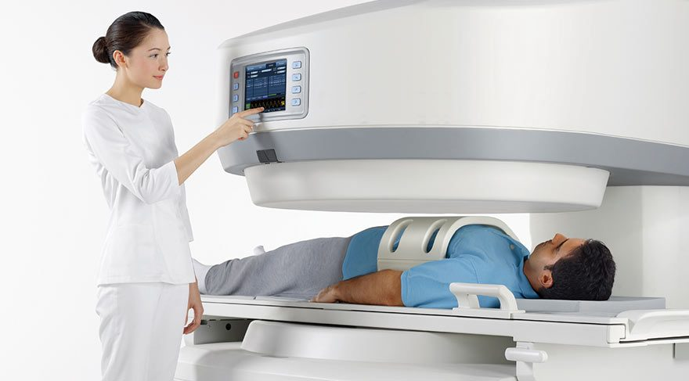
Figure 1. Image Text (Times new roman, 10 font size)

Table 10 pt. Table No. Part bold, Name of the table Each word capital letter 1 space after the name of the table (1-line spacing 10punto, before and after 0nk). Only horizontal lines should be used with text inside the table 10 pt. 1 line spacing before and after 0 pt. Vertical lines should never be used. (Decimal notation in the table should be indicated with a dot).

Table 1. Some Analytical Characteristics for Aflatoxin B1, B2, G1 and G2

Aflatoksin | Alıkonma Zamanı  (dk) | LOD  (µg/L) | LOQ  (µg/L) | Lineer Ölçüm Aralığı  (µg/L) | R²
B₁ | 8.443 | 0.036 | 0.120 | 0.125-2.5 | 0.9983
B₂ | 10.233 | 0.030 | 0.100 | 0.125-2.5 | 0.9990
G₁ | 12.320 | 0.021 | 0.070 | 0.125-2.5 | 0.9981
G₂ | 14.718 | 0.024 | 0.080 | 0.125-2.5 | 0.9986

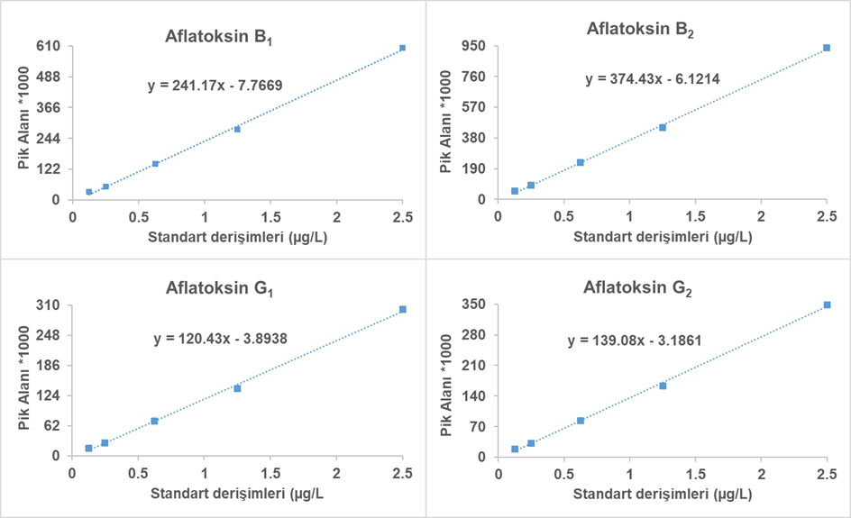
Figure 1. Aflatoxin (B1, B2, G1, G2) Calibration Graphs
Figures should be under the title of the Figures Issue. The part should be bold, the text part should be normal 10 pt, 1 line spacing before and 0 pt after.
DISCUSSION (It can also be presented as separate headings. See headings in the spelling rules...)
Times New Roman 12 pt, 1.5 line spacing 0 pt before and after, justified. 1 cm indent. Only 10 pt should be added after the last line. Times New Roman 12 pt, 1.5 line spacing 0 pt before and after, justified. 1 cm indent. Only 10 pt should be added after the last line. Times New Roman 12 pt, 1.5 line spacing 0 pt before and after, justified. 1 cm indent. Only 10 pt should be added after the last line. Times New Roman 12 pt, 1.5 line spacing 0 pt before and after, justified. 1 cm indent. Only 10 pt should be added after the last line. Times New Roman 12 pt, 1.5 line spacing 0 pt before and after, justified. 1 cm indent. Only 10 pt should be added
Limitations of the Study
In all subheadings, the first letter of each word is capitalised and bolded. Times New Roman 12 pt, 1.5 line spacing before-after 0 pt, justified. 1 cm indent. Only 10 pt should be added after the last line.
CONCLUSION
Times New Roman 12 pt, 1.5 line spacing 0 pt before and after, justified. 1 cm indent. Only 10 pt should be added after the last line. Times New Roman 12 pt, 1.5 line spacing 0 pt before and after, justified. 1 cm indent. Only 10 pt should be added after the last line. Times New Roman 12 pt, 1.5 line spacing 0 pt before and after, justified. 1 cm indent. Only 10 pt should be added after the last line. Times New Roman 12 pt, 1.5 line spacing 0 pt before and after, justified. 1 cm indent. Only 10 pt should be added after the last line
Ethics Committee Approval: XXXXX
Informed Consent: XXXX
Peer-review: Externally peer-reviewed.
Financial Disclosure:
Acknowledgements
Times New Roman 12 pt, 1.5 line spacing before-after 0 pt, justified. 1 cm indent. Only 10 pt should be added after the last line.
Note:
Articles derived from a thesis, abstracts, and articles presented within the scope of a program should be indicated in this section. Times New Roman 12 pt, 1.5 line spacing, 0 pt before and after, justified. 1 cm indent. Only 10 pt should be added after the last line. Author contribution and conflict of interest should be included in the last part. This information should be included in the Title Page file when the article is uploaded.
REFERENCES (TNR 10p, bold, 1 line spacing 0 before, 10 pt after)
1.Burtin C, Saey D, Saglam M, Langer D, Gosselink R, Janssens W, et al. Effectiveness of exercise training in patients with COPD: the role of muscle fatigue. Eur Respir J. 2012;40(2):338-44.
2.Hielkema T, Hadders Algra M. Motor and cognitive outcome after specific early lesions of the brain–a systematic review. Dev Med Child Neurol. 2016;58(Suppl 4):46-52.
3.Murtagh J. John Murtagh’s general practice. 4th ed. Sydney: McGraw-Hill Australia Pty Ltd; 2007.
4.Cerulli G. Treatment of athletic injuries: what we have learned in 50 years. In: Doral MN, Tandogan RN, Mann G, Verdonk R, eds. Sports injuries. Prevention, diagnosis, treatment and rehabilitation. Berlin: Springer-Verlag; 2012: p. 15-9.
5.Callaghan MJ, Guney H, Bailey D, Reeves N, Kosolovska K, Maganaris K, et al. The effect of a patellar brace on patella position using weight bearing magnetic resonance imaging. 2014 World Congress of Osteoarthritis Research Society International, April 24-27, 2014, Paris. Osteoartr Cartilage; 2014;22(Suppl):S55.
6. Diabetes Australia. Gestational diabetes [Internet]. Canberra (AU): Diabetes Australia; 2015 [updated 2015; cited 2017 Nov 23]. Available from: https://www. diabetesaustralia.com.au/gestational-diabetes.

